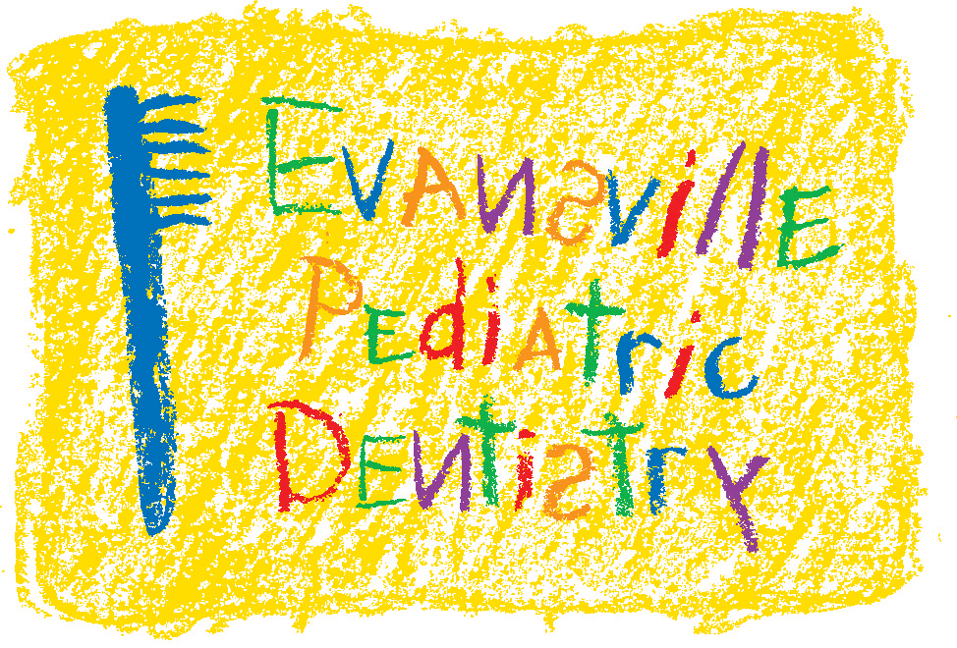

Brushing and Flossing Chart

Sunday | Monday | Tuesday | Wednesday | Thursday | Friday | Saturday
□  □  Brush Twice Daily    Floss Once Daily  □ | □ □  Brush Twice Daily  Floss Once Daily  □ | □ □  Brush Twice Daily  Floss Once Daily  □ | □ □  Brush Twice Daily  Floss Once Daily  □ | □ □  Brush Twice Daily  Floss Once Daily  □ | □ □  Brush Twice Daily  Floss Once Daily  □ | □ □  Brush Twice Daily  Floss Once Daily  □
□ □  Brush Twice Daily  Floss Once Daily  □ | □ □  Brush Twice Daily  Floss Once Daily  □ | □ □  Brush Twice Daily  Floss Once Daily  □ | □ □  Brush Twice Daily  Floss Once Daily  □ | □ □  Brush Twice Daily  Floss Once Daily  □ | □ □  Brush Twice Daily  Floss Once Daily  □ | □ □  Brush Twice Daily  Floss Once Daily  □
□ □  Brush Twice Daily  Floss Once Daily  □ | □ □  Brush Twice Daily  Floss Once Daily  □ | □ □  Brush Twice Daily  Floss Once Daily  □ | □ □  Brush Twice Daily  Floss Once Daily  □ | □ □  Brush Twice Daily  Floss Once Daily  □ | □ □  Brush Twice Daily  Floss Once Daily  □ | □ □  Brush Twice Daily  Floss Once Daily  □
□ □  Brush Twice Daily  Floss Once Daily  □ | □ □  Brush Twice Daily  Floss Once Daily  □ | □ □  Brush Twice Daily  Floss Once Daily  □ | □ □  Brush Twice Daily  Floss Once Daily  □ | □ □  Brush Twice Daily  Floss Once Daily  □ | □ □  Brush Twice Daily  Floss Once Daily  □ | □ □  Brush Twice Daily  Floss Once Daily  □

